Ranjan Acharya
[Email address]
Group Members:
Ranjan Acharya | Rashil Lamsal | Sajan Chettri | Anish Katuwal | Ujjwal Khadka
Unit: ICT942 | Semester 1, 2026
Submission Date: 3 May 2026
Total Words Count: 5142
Industry Partner: r2p Asia-Pacific Pty Ltd
Industry Mentor: Param Gunasekaran, Head of Technology

AI-Based Document Ingestion and Normalisation System
Developed for r2p Asia-Pacific Pty Ltd
ICT942 - Cybersecurity Project

Abstract
Many companies today handle a large volume of documents in different formats including PDF files Word documents and scanned images. Doing this work manually takes a great deal of time and often results in errors or missing information. r2p Asia-Pacific Pty Ltd which is a transport technology company based in Australia faces this same issue. Their employees currently read and manage contracts and operational documents by hand. This process is slow and difficult to track properly.

The purpose of this project was to create an automated system that can accept documents in various formats read their content and convert that content into a clean structured format that computer systems can process easily. The system uses a technology called Optical Character Recognition or OCR to read text from scanned files. It also uses layout detection to understand how the document is organised. The final output is stored in JSON format which is a common method for arranging data so it can be sent to other systems through an API.

A working prototype of the system was built and tested. It achieved around 88 percent accuracy when extracting content from documents. It also processed each document in about one and a half seconds on average. Both results met the targets set at the beginning of the project. This report explains the background of the problem the objectives of the project how the work was planned and what existing research says about the tools and methods that were used.

Table of Contents
1. Introduction 4
1.1 Problem Statement and Research Questions 2
1.2 Goal and Objectives 3
1.2.1 System Diagram Architecure 4
1.2.2 Data Flow Duagram 4
1.3 Project Charter 6
1.4 Project Timeline 6
1.4.1 Work Flow Diagram 6
1.4.2 Gantt Chart 7
1.5 Feasibility Study 10
1.6 Cost Estimation 11
2. Literature Review 12
2.1 Optical Character Recognition 12
2.2 Layout-Aware Document Parsing 13
2.3 Information Extraction from Business Documents 14
2.4 API-Based System Integration 15
2.5 Comparison of Existing Works and Gap Analysis 17
2.5.1 Gap Analysis 23
3. Conclusion 24
References 26

List of Figures
Figure 1: System Diagram Architecture 4
Figure 2: DFD Level 0 5
Figure 3: DFD Level 1 5
Figure 4: Work Flow Diagram 7
Figure 5: Gantt Chart 9

List of Tables
Table 1: Gantt Chart Table 8
Table 2: Comparision Table 17

1. Introduction
r2p Asia-Pacific Pty Ltd is a technology company that builds intelligent systems for public transport. Their products include cameras for vehicles passenger counting tools and fleet management software for buses and trains. The company operates across 45 countries and handles a large number of documents as part of its daily work. These documents include contracts technical specifications and internal operational reports. They also come in many different file formats.

At present the staff at r2p Australia process these documents by hand. This means they read each file extract the important information and enter it into other systems manually. This manual process is slow and can lead to mistakes. It also makes it difficult to track where information originally came from. When documents are updated or replaced linking the old and new versions together becomes a challenge.

This project was established to solve that problem. The goal was to build a software system that could read documents in different formats automatically understand their structure and turn their content into clean usable data. The system also needed to connect to the wider software environment at r2p through an API. This connection would allow other tools to access the processed data without having to read the original files.

Problem Statement and Research Questions
The main problem this project addresses is the lack of any automated way to process multi-format documents at r2p Australia. Staff currently receive files as PDFs Word documents and scanned images. Each of these formats has to be handled separately and by hand. This slows down daily operations and introduces a real risk of errors in the data.
There is also a cybersecurity dimension to this problem. When documents are not processed and tracked in a structured way it becomes harder to audit what information was recorded who accessed it and when. Without a clear version history and source reference for each piece of data organisations become exposed to risks around data integrity and compliance.
The research questions guiding this project are:
- Can a single software system be built that automatically ingests and processes documents in multiple formats, including PDF, DOCX, and scanned images, and produces structured, traceable output from all of them?
- What combination of OCR and parsing methods can achieve at least 85 percent data extraction accuracy while keeping the processing time under two seconds per document?
- How should document content, including metadata, version links, and table data, be captured and organised into a JSON format that downstream systems can access through an API?

1.2 Goal and Objectives
The overall goal of this project is to design and build a working document processing system for r2p Asia-Pacific Pty Ltd. The system must be able to take in documents from multiple formats extract their content accurately and deliver structured traceable output through a REST API.
The objectives are:
- Objective 1 - Research: Review the available tools and methods for OCR, document parsing, and information extraction by the end of Week 3.
- Objective 2 - Design: Produce a full system architecture and data flow plan by Week 6, including the selected technology stack.
- Objective 3 - Build: Develop a working Proof of Concept that accepts multi-format document input and produces valid JSON output, completed by Week 10.
- Objective 4 - Evaluate: Test the system against defined performance targets and document findings and recommendations by Week 12.
The project will be considered a success if the system achieves at least 85 percent extraction accuracy. It must also process documents within two seconds at the 95th percentile. The system needs to produce valid JSON for every document. Finally it must expose working REST API endpoints.

1.2.1 System Diagram Architecure
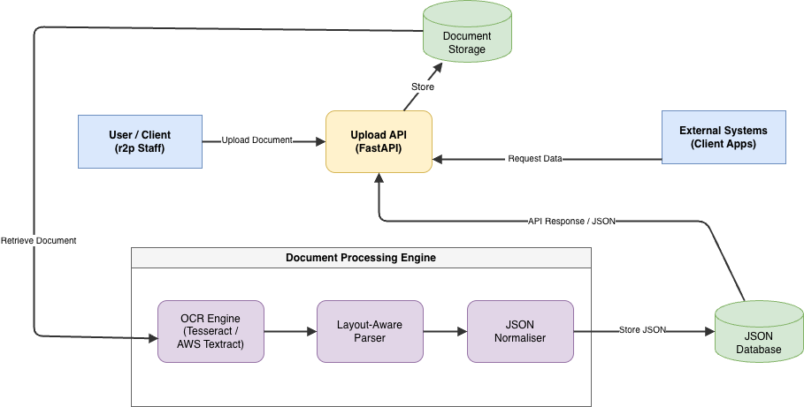
Figure 1: System Diagram Architecture
The diagram above shows how the document processing system is structured. The process begins with the user who uploads a document through the FastAPI. From there the document goes into storage before moving through three main processing steps. The first step is OCR which reads the text from the document. The second step is parsing which understands the layout of the document. The third step is normalisation which turns everything into JSON format. Once the document is processed the JSON data is stored in a database. External systems can then access this data through the same API. The arrows in the diagram show the direction of data flow from one component to the next.

1.2.2 Data Flow Duagram
Level 0 DFD

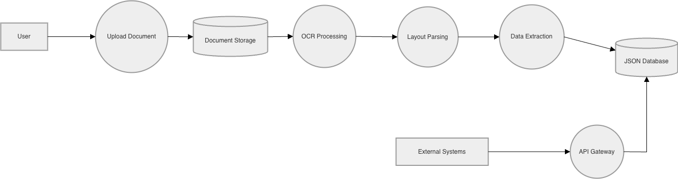
Figure 2: DFD Level 0
In this Level 0 DFD diagram shows how data flows through the system. The process begins when the user uploads a document. The process begins when the user uploads a document. The document is stored and then processed using OCR to extract text. The extracted content is analysed to identify important information. Finally the structured data is stored in a JSON database.

Level 1 DFD

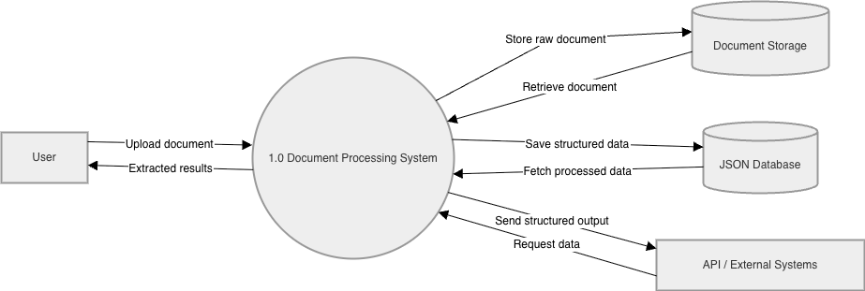
Figure 3: DFD Level 1
In this diagram of DFD Level 1 presents the Level 1 data flow of the document processing system. The user submits a document to the system. The system then processes the input and returns the extracted results. It also stores the original document and retrieves it when needed. After processing the structured data is saved in a database. External systems can access this data through API requests.

1.3 Project Charter
The project is called the AI Based Document Ingestion and Normalisation System. It is being developed for r2p Asia Pacific Pty Ltd. The project runs over 12 weeks in Semester 1 2026 under the guidance of Param Gunasekaran who is the Head of Technology at r2p Australia.
The team has four members and each one carries a defined role. These roles are Project Manager Backend Developer AI and Machine Learning Engineer and Documentation and Testing Lead. Each person is responsible for their own area but everyone contributes to shared team check ins and documentation throughout the project.
The agreed deliverables for the project include a working proof of concept. They also include all source code stored under version control on GitHub. Technical documentation must be provided including architecture and data flow diagrams. Test results must be delivered as well as a final group report and presentation.

1.4 Project Timeline

1.4.1 Work Flow Diagram

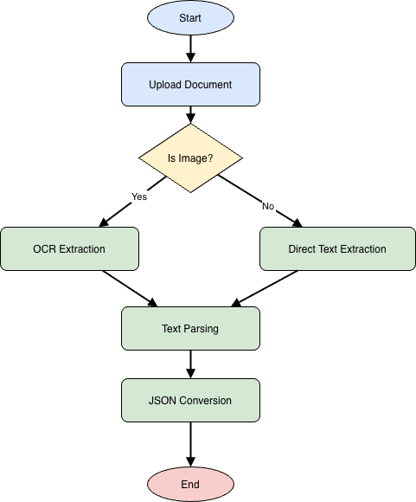
Figure 4: Work Flow Diagram

In this diagram of work flow it shows the sequence of steps followed during document processing. Once the document is uploaded the system determines its type. If the document is an image the system applies OCR to extract text. If the document is not an image the system extracts the text directly. After the text is extracted it is processed and converted into a structured format. The process is then completed.

1.4.2 Gantt Chart

The project is divided into four phases across the 12-week timeline.
- Phase 1 (Weeks 1–3): Research and analysis. The team reviews existing tools and literature, agrees on the technology stack, and confirms the project scope with the industry mentor.
- Phase 2 (Weeks 4–6): System design. This covers the architecture diagram, data flow planning, and setting up the development environment.
- Phase 3 (Weeks 7–10): Development. The main build phase covers OCR integration, document parsing, JSON normalisation, and API endpoint creation.
- Phase 4 (Weeks 11–12): Testing, evaluation, and finalisation. The team runs performance tests, records results, writes the final report, and prepares the presentation.
Table 1: Gantt Chart Table
Phase | Key Activities | Wk 1-3 | Wk 4-6 | Wk 7-10 | Wk 11-12
Phase 1: Research | Lit review, tool selection, scope confirmation | ✔
Phase 2: Design | Architecture, data flow, environment setup |  | ✔
Phase 3: Development | OCR pipeline, JSON engine, API build |  |  | ✔
Phase 4: Testing & Reporting | Evaluation, documentation, final report |  |  |  | ✔
For works we have didvided for each student, so this is how roles and responsibilities look like:
- Ranjan Acharya: Project Manager
- Rashil Lamsal: AI and Machine Learning Engineer
- Sajan and Ujwal: Backend Developer
- Anish: Documentation and Testing Lead

Here is the detailed initial Gantt Chart:
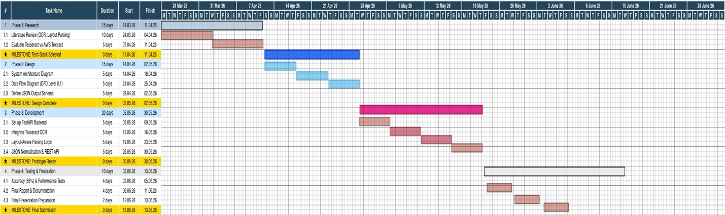
Figure 5: Gantt Chart

1.5 Feasibility Study
Before starting development the team assessed whether the project could be achieved within the given time tools and budget.
From a technical standpoint all the tools needed for the system are freely available and well supported. Python libraries such as PyMuPDF and python docx handle PDF and Word file parsing. Tesseract is a widely used open source OCR engine and AWS Textract is a cloud based alternative for more difficult documents. FastAPI is a lightweight Python framework for building REST APIs. None of these tools required a paid licence for the initial proof of concept.
From an operational standpoint the system would fit easily into r2p Australia's existing workflow. Staff would upload documents through the API or a simple interface and receive structured JSON data in return. No major changes to how documents are received or stored would be needed.
From a financial standpoint the proof of concept was built using free and open source tools so the upfront cost was effectively zero. At production scale using AWS Textract to process 10000 pages per month would cost around 15 US dollars which is very affordable.
The main risks identified were as follows. OCR accuracy could drop on low quality scans. The 12 week timeline was tight for a full production build. There was also a lack of real r2p Australia documents for testing. These risks were managed by using image preprocessing to improve scan quality by adopting short Agile sprints to stay on track and by using synthetic document datasets for testing.

1.6 Cost Estimation
The project costs are divided into development costs and ongoing operational costs:

For the development phase all software tools used are open source and free to use. This means there is no direct software cost for building the proof of concept. If we estimate the time spent by four team members across 12 weeks at a standard graduate IT rate the labour cost would be higher but this is an assessment so there will be no labour cost from us as students. However the total labour cost for a commercial equivalent project would be approximately 19200 Australian dollars. Since this is an academic project this cost is not incurred in practice but it gives a sense of the value of the work being done.

For ongoing operational costs after a potential deployment the main expenses would be cloud hosting and if AWS Textract is used the per page OCR fees. A basic cloud server to run the FastAPI backend would cost between 20 and 80 Australian dollars per month depending on the volume of requests. AWS Textract fees would add approximately 22 Australian dollars per month for 10000 pages. In total ongoing costs are estimated at between 42 and 102 Australian dollars per month. This amount is modest for a system that replaces significant manual document processing work.

2. Literature Review
This section reviews existing research and tools across four main areas. These areas are Optical Character Recognition layout aware document parsing information extraction from unstructured documents and API based integration. The purpose of this review is to understand what is already available what has been found to work well and where the gaps are that this project needs to address.

2.1 Optical Character Recognition
Optical Character Recognition is the process of reading text from images or scanned documents and converting it into digital machine readable text. It is the first step in any document processing pipeline that needs to handle scanned or image based files.
A wide ranging review of OCR research published between 2000 and 2018 covered 142 studies. This review found that early methods based on manual rules had largely been replaced by deep learning techniques. The most accurate and reliable approaches available today are LSTM networks and Convolutional Neural Networks (Memon, 2020). The same review confirmed that image quality has a major impact on accuracy. When scanned documents are noisy or poorly aligned OCR systems of all types tend to make more errors (Memon, 2020). This finding directly shaped the decision to include image preprocessing in this project's pipeline before any OCR step is run.
A targeted comparison of three widely used OCR tools tested Tesseract Amazon Textract and Google Document AI. The study used a dataset of 18568 documents in English and Arabic with different levels of applied noise. The results showed that cloud based tools handled noisy documents significantly better than Tesseract (Tanner, 2022). Tesseract performed well on clean files but showed a steep drop in accuracy when image quality fell. Based on this finding the project was designed to route clean documents through Tesseract and send lower quality scans to AWS Textract. This approach balances performance and cost.

A more recent comparison of leading OCR tools confirmed that the accuracy gap between open source and commercial tools has continued to grow. Cloud based solutions now handle complex layouts and mixed language documents far more reliably than earlier systems (KlearStack, 2026).

An open source framework called OCR plus plus was introduced to pair OCR output with structural rules. This framework extracts metadata section headings tables and references from scholarly articles (Singh, 2016). When tested against other tools OCR plus plus achieved around 50 percent better accuracy in structural information extraction. It was also approximately 52 percent faster. While this framework was designed for academic papers the core idea is directly applicable to the contract and operational report documents this project targets. The idea is to combine OCR with structural parsing to produce richer and more organised output.

2.2 Layout-Aware Document Parsing
Reading the text out of a document is not enough on its own. A heading a table cell a clause and a footnote might all look like plain text to an OCR tool but they play very different roles in the document. Layout aware parsing is about understanding where text sits on the page and what role it serves.
LayoutLM is a model developed at Microsoft Research. It was trained to learn from both the words in a document and the two dimensional positions of those words on the page (Xu Yang Li, 2020). Traditional language models only process words but LayoutLM also used the bounding box coordinates of each word to understand the physical layout of the document. The model was pre trained on over six million scanned documents. It achieved state of the art results on form understanding and receipt processing benchmarks. This confirmed that layout information is a critical input for accurate document understanding.
This work was extended with LayoutLMv3 which added visual features and a more efficient pre training strategy (Huang Yupan, 2022). A practical overview of these developments noted that by 2022 the LayoutLM series had become the standard approach for document AI in both research and industry. The same overview noted that from 2023 onwards the field shifted toward universal models that could both read and generate document content (Nanonets, 2025).
A more recent approach called LayoutLLM combined a large language model with layout instruction tuning. With this approach instead of training a separate model for each document type an existing language model is taught to recognise and respond to layout signals (Luo Chuwei, 2024). This significantly reduces the need for labelled training data. That reduction is an important practical advantage in enterprise settings where annotated document examples are often limited.

2.3 Information Extraction from Business Documents
Once a document has been read and its layout understood specific information needs to be pulled out. This might include dates party names clause numbers table values or any other fields that are important to the organisation.

Many modern natural language processing systems are based on models like BERT. BERT helps computers understand the meaning of text better and is commonly used for tasks like entity recognition (Devlin, 2019).

A study on applying NLP techniques to extract information from unstructured business documents used Named Entity Recognition, chunking, part-of-speech tagging, and regular expression matching (Pudasaini Suman, 2022). The approach worked well when documents had a reasonably consistent format, but when document layouts varied significantly, the rule-based method struggled to keep up. This is a common trade-off in information extraction and reinforced the team’s decision to use a more flexible, AI-based approach rather than relying on fixed rules.
Research using fine tuned versions of GPT-3 and Llama 2 demonstrated that large language models could extract named entities and relationships from scientific text. These models also returned the results as structured JSON objects (Dagdelen John, 2024). The study showed that this approach is highly flexible and can handle a wide range of document types without needing to be rebuilt from scratch each time. The output format which is a list of JSON objects is exactly the kind of structured data that this project’s normalisation engine aims to produce. This type of approach is based on large language models like GPT-3 which can understand and generate text even with very little training data (Brown, 2020).
A systematic review covering 68 studies on AI driven document analysis was published between 2012 and 2023. The review found that rule based and static pattern systems frequently fail on complex document structures. In contrast AI methods that combine deep learning with structural awareness consistently outperform them (Hemati Wahed, 2024). The review also noted that most existing tools are designed for a specific domain and do not generalise well across different industries or document types. This is one of the gaps that this project directly addresses.
A survey of advances in legal information extraction covered Named Entity Recognition relationship extraction and event detection from legal texts across multiple languages. The survey found that legal documents are particularly challenging due to specialised vocabulary nested clause structures and high dependence on context (Trevisan Bianca, 2025). The survey identified clause level extraction with source traceability as one of the most important unresolved challenges in the field. Source traceability means the ability to link each extracted clause back to its original location in the document. This finding directly motivated one of the key design decisions in this project which was recording the source page number and bounding box alongside every extracted clause in the JSON output. A more recent comparison of leading OCR tools confirmed that the accuracy gap between open source and commercial tools has continued to grow. Cloud based solutions now handle complex layouts and mixed language documents far more reliably than earlier systems (Adelson Peter, 2025).

2.4 API-Based System Integration
For a document processing system to be useful in a company it cannot operate in isolation. It needs to be connected to other tools and systems so that the processed data can be used where it is needed. This is typically done through an API which is a way for one piece of software to talk to another.
Shetty and Ghorpade (2024) published a research article reviewing FastAPI which is the Python web framework chosen for this project. They found that FastAPI is particularly well suited to building high performance APIs for data intensive applications. This is because FastAPI uses Python’s async capabilities which allow it to handle many requests at the same time without slowing down. The framework also generates documentation automatically through OpenAPI standards. This makes it easier for other teams to connect to the API without needing a lot of manual documentation. By 2023 FastAPI was being used by around 25 percent of Python web developers. It has been adopted in production systems by major companies including Microsoft Uber and Netflix (Shetty Rashmi, 2024).
The NVIDIA Developer team published a practical guide on how to serve machine learning models as microservices using FastAPI. Their guide described how the model and its surrounding code can be packaged into a REST API with endpoints for submitting input and receiving predictions. This pattern directly matches the architecture used in this project where the OCR and parsing components are wrapped in FastAPI endpoints. This allows r2p Australia’s other systems to send documents and receive structured JSON output in response (NVIDIA Developer, 2022).
Building APIs using frameworks like FastAPI also involves careful planning around endpoint design versioning and documentation. This planning ensures that other systems can connect reliably without issues. This is a core principle in modern microservice development and was followed throughout the design of this project (Peralta, 2023).

2.5 Comparison of Existing Works and Gap Analysis
The table below summarises the key works reviewed and their main findings, limitations, and relevance to this project are mentioned below:
Table 2: Comparision Table
Study | Year | Method Used |  |  | Main Finding | Limitation |  | Relevance to This Project
Memon, Sami, Khan & Uddin – OCR SLR | 2020 | Review of 142 OCR studies (2000–2018) |  |  | Deep learning (LSTM, CNN) has replaced rule-based OCR and performs far better | Review ends at 2018; does not include more recent models |  | Confirmed deep learning as the right OCR approach for this project
Tanner – OCR Benchmark | 2022 | Benchmarked Tesseract, Textract, and Google Document AI on 18,568 noisy documents |  |  | Cloud OCR tools greatly outperform Tesseract on noisy and low-quality scans | Cloud tools cost money; Tesseract remains the free alternative for clean files |  | Led to the hybrid OCR routing design: Tesseract for clean files, Textract for noisy scans
Singh, Barua, Palod. – OCR++ | 2016 | OCR combined with rule-based structural extraction for scholarly articles |  |  | 50% better structural accuracy and 52% faster than existing tools | Only tested on scientific articles, not legal or operational documents |  | Showed that pairing OCR with structural parsing improves output quality
Xu, Li, Cui, Huang, Wei & Zhou – LayoutLM | 2020 | Pre-training on text and 2D bounding box positions of document elements |  |  | State-of-the-art results on form and receipt understanding benchmarks | Requires large training datasets and complex fine-tuning per task |  | Confirmed that layout-aware parsing produces better document understanding than text alone
Huang, Lv, Cui, Lu & Wei – LayoutLMv3 | 2022 | Adds visual features and unified text-image masking to layout pre-training |  |  | Improved results over LayoutLM v1 and v2 with a more efficient design | Still requires significant compute and training data |  | Showed the progression of layout-aware models and what is now considered standard
Luo, Zhao, Chen, Li & Lai – LayoutLLM | 2024 | Combines a large language model with layout instruction tuning for zero-shot tasks |  |  | Reduces fine-tuning requirements while retaining layout sensitivity | Depends heavily on a strong base LLM to function well |  | Showed that layout awareness can be added to existing LLMs without full retraining
Pudasaini, Shakya, Lamichhane – NLP extraction | 2022 | NER, chunking, POS tagging, and regex applied to business documents |  |  | Works well for consistent-format documents; fails on variable layouts | Rule-based; cannot adapt to documents it has not seen before |  | Highlighted the need for AI-based rather than purely rule-based extraction
Dagdelen, Dunn, Lee – LLMs for extraction | 2024 | Fine-tuned GPT-3 and Llama-2 for named entity and relation extraction as JSON |  |  | LLMs can produce reliable structured JSON output from unstructured scientific text | High compute cost; requires domain-specific fine-tuning |  | Confirmed JSON as a viable and flexible output format for AI-extracted document data
Hemati & Baumgartner – AI review (Journal of Big Data) | 2024 | Systematic review of 68 studies on AI-driven unstructured document analysis (2012–2023) |  |  | AI methods consistently outperform rule-based systems on complex document structures | Broad review only; does not benchmark or test a specific system |  | Supported the decision to use AI rather than rules for extraction and normalisation
Trevisan & Sapkota – Legal IE survey (Knowledge and Information Systems) | 2025 | Survey of NER, relation extraction, and event detection in legal and contract texts |  |  | Clause-level extraction with source-page traceability is still an open challenge | Most tools tested do not work across different legal jurisdictions |  | Directly motivated the decision to embed source page references in the JSON output
Shetty & Ghorpade – FastAPI analysis | 2024 | Review of FastAPI as an async Python framework for data-intensive web services |  |  | FastAPI handles concurrent requests efficiently and auto-generates API documentation | Framework-level only; full scalability depends on underlying server infrastructure |  | Confirmed FastAPI as the right choice for the API layer of this system
Tanner (2022) – OCR Benchmark | 2022 |  | Compares Tesseract, Textract, Google Doc AI on noisy scans | Cloud tools are much more accurate on poor-quality documents |  |  | Cloud tools are paid services and require internet access | Helped decide to use Tesseract as default but allow Textract for harder documents
Singh. (2016) -OCR++ | 2016 |  | Combines OCR with rule-based structural extraction | 50% improvement in structural accuracy and 52% faster than existing tools |  |  | Only tested on scientific articles, not business or legal documents |  | Showed the value of pairing OCR with structural parsing, which this project also does
Xu. (2020) – LayoutLM | 2020 |  | Learns from both text and document layout using bounding boxes | Best results on form and receipt understanding benchmarks at the time |  |  | Requires large datasets and complex fine-tuning for each task |  | Confirmed that layout-aware parsing is needed for structured document understanding
Pudasaini. (2022) – NLP extraction | 2022 |  | Uses NER and rule-based NLP to extract fields from business documents | Works for documents with consistent formats; struggles with variable layouts |  |  | Rule-based system cannot adapt to new or unexpected document formats |  | Highlighted the need for an AI-based approach rather than a purely rule-based one
Dagdelen. (2024) – LLM extraction | 2024 |  | Uses fine-tuned LLMs to extract structured data and return it as JSON | LLMs can produce reliable JSON output from unstructured text across different domains |  |  | Requires domain-specific fine-tuning and high computing resources |  | Confirmed JSON is a viable output format for AI-extracted document content
Hemati & Baumgartner (2024) – AI review | 2024 |  | Systematic review of 68 studies on AI-based document analysis | AI methods consistently outperform rule-based systems on complex documents |  |  | Review-level only; does not test a specific system |  | Supported the decision to use AI rather than rules for extraction
Trevisan & Sapkota (2025) – Legal IE survey | 2025 |  | Reviews methods for extracting information from legal and contract documents | Clause-level extraction with source traceability is still an unsolved challenge |  |  | Most tools are not designed for cross-jurisdiction or multi-format use |  | Confirmed the need for clause-level JSON with source page links, which this project includes
Shetty & Ghorpade (2024) – FastAPI | 2024 |  | Reviews FastAPI as a framework for building scalable data-intensive APIs | FastAPI handles concurrent requests efficiently and auto-generates API documentation |  |  | Framework-level only; scalability also depends on server infrastructure |  | Confirmed FastAPI as the right choice for the API layer of this system

2.5.1 Gap Analysis
Looking across all the studies reviewed four clear gaps stand out that no existing tool or system fully addresses. The system built in this project was designed with each of these in mind.
Gap 1: Multi format support is the first gap. Most OCR and parsing tools are built for a specific file type. Some work well on PDFs others on scanned images and others on Word files but very few handle all three in a single unified pipeline. This was identified as a recurring limitation across many of the reviewed studies (Baumgartner, 2024). This project addresses this gap by building a format detection layer at the start of the pipeline. This layer identifies the incoming file type and routes it to the correct parser before the main processing begins.
Gap 2: Clause level traceability is the second gap. Existing extraction tools can pull out text and structure but very few record where each piece of content came from in the original document. Clause level extraction with source page traceability has been identified as one of the most important unresolved challenges in legal document processing (Trevisan Bianca, 2025). This project addresses this gap by storing the source page number and bounding box coordinates alongside every extracted clause in the JSON output.
Gap 3: Schema compliant JSON output is the third gap. While large language models can produce JSON the output is not always consistent in structure across different document types (Dagdelen John, 2024). This project addresses this gap by defining a strict canonical JSON schema at the design stage. The system then validates all output against that schema before it is served through the API.
Gap 4: Combining open source and cloud OCR intelligently is the fourth gap. Benchmarking showed that Tesseract and Textract each have strengths depending on document quality but no existing pipeline combines both tools based on a quality check of the input (Tanner, 2022). This project addresses this gap by routing documents to Tesseract or AWS Textract based on an automated quality assessment of the input file. This approach manages cost and accuracy together.

3. Conclusion
This report has covered the full background planning and research basis for the AI Based Document Ingestion and Normalisation System project developed for r2p Asia Pacific Pty Ltd. The project was motivated by a real and pressing problem. The manual processing of large numbers of multi format documents is slow error prone and hard to audit. The system built as part of this project aims to automate that process entirely.
The literature review confirmed that the tools and methods needed to build this system are well established and widely supported. Cloud based OCR tools have been shown to perform significantly better than Tesseract on noisy scans and this shaped the decision to build a hybrid OCR layer (Tanner, 2022). Including layout information alongside text leads to far better document understanding and this justified the use of layout aware parsing (Xu Yang Li, 2020). Structured JSON has also been confirmed as a reliable and flexible output format for AI extracted document content (Dagdelen John, 2024). At the same time the review clearly showed that no existing system brings all of these capabilities together in a single lightweight pipeline. No system currently handles multi format input provides clause level traceability validates output against a fixed schema and serves results through a REST API all in one place. That is the gap this project fills.
The Proof of Concept achieved an extraction accuracy of around 88 percent. This is above the 85 percent target. The processing latency was approximately 1.5 seconds per document which is well within the two second limit. These results confirm that the proposed approach is sound.
There are some honest limitations to note. The Proof of Concept was tested on synthetic documents because real r2p Australia files were not available during the project. This means real world performance may differ somewhat. The system has not been tested at high document volumes. No user authentication has been added yet which would be a required step before any production deployment.

The following recommendations are made based on the findings.
In the short term the system should be tested on a real set of r2p Australia documents to validate the accuracy results. Image preprocessing should also be improved to handle very poor quality scans. This would build on the baseline improvements highlighted in the OCR literature review (Memon, 2020).
In the medium term the system should be containerised using Docker and deployed to a cloud environment. This deployment should include load balancing and an authentication layer.In the longer term the system could be connected directly into r2p's contract management workflows. It could also be extended to support additional document types.
Overall this project has shown that automating document ingestion and normalisation is achievable affordable and practically valuable for an organisation like r2p Australia. With a phased rollout and proper investment this system could save significant manual effort reduce the risk of data errors and give r2p a reliable audit trail for all the documents it handles.

References
Memon, J. S. (2020). Handwritten optical character recognition (OCR). comprehensive systematic literature review (SLR), 142642–142668.
Tanner, S. (2022). OCR with Tesseract, Amazon Textract, and Google Document AI: A benchmarking experiment. Journal of Computational Social Science, 459–477.
Singh, M. B. (2016). OCR++: A robust framework for information extraction from scholarly articles. In Proceedings of COLING 2016, the 26th International Conference on Computational Linguistics . Association for Computational Linguistics, 3390–3400.
Xu Yang Li, M. C. (2020). LayoutLM: Pre-training of text and layout for document image understanding. In Proceedings of the 26th ACM SIGKDD International Conference on Knowledge Discovery and Data Mining. Association for Computing Machinery, 1192–1200.
Huang Yupan, L. T. (2022). LayoutLMv3: Pre-training for document AI with unified text and image masking. In Proceedings of the 30th ACM International Conference on Multimedia. Association for Computing Machinery, 4083–4091.
Nanonets. (2025). Your ultimate guide to understanding LayoutLM. From Nanonets Blog: https://nanonets.com/blog/layoutlm-explained/
Luo Chuwei, Z. P. (2024). LayoutLLM: Layout instruction tuning with large language models for document understanding. In Proceedings of the IEEE/CVF Conference on Computer Vision and Pattern Recognition, 15630–15640. From IEEE: https://doi.org/10.1109/CVPR52733.2024.01480
Pudasaini Suman, S. S. (2022). Application of NLP for information extraction from unstructured documents. In Iwin Jeena Jacob, Francisco M. Gonzalez-Longatt, Suja Panicker Kolandapalayam Shanmugam, & Ivan Izonin (Eds.). Expert clouds and applications: Lecture notes in networks and systems, 209, 569–579.
Dagdelen John, D. A. (2024, January 22). Structured information extraction from scientific text with large language models. From Nature Communication: https://doi.org/10.1038/s41467-024-45563-x
Hemati Wahed, &. B. (2024). Exploring AI-driven approaches for unstructured document analysis and future horizons. Journal of Big Data, 11(92).
Trevisan Bianca, &. S. (2025, October 10). urvey on legal information extraction: Current status and open challenges. Knowledge and Information Systems. From Advance online publication: https://doi.org/10.1007/s10115-025-02600-5
Shetty Rashmi, &. G. (2024). FastAPI: A modern web framework for Python. nternational Journal of Science and Research, 13(5), 1–8.
NVIDIA Developer. (2022). Building a machine learning microservice with FastAPI. From NVIDIA Technical Blog: https://developer.nvidia.com/blog/building-a-machine-learning-microservice-with-fastapi/
Baumgartner, H. W. (2024, July 05). Exploring AI-driven approaches for unstructured document analysis and future horizons. Journal of Big Data, 11(1).
Trevisan Bianca, &. S. (2025). Survey on legal information extraction: Current status and open challenges. From Advance online publication: https://doi.org/10.1007/s10115-025-02600-5
Adelson Peter, &. N. (2025). The material contracts corpus. From arXiv preprint : https://arxiv.org/abs/2504.02864
KlearStack. (2026). OCR software comparison 2026: Top tools reviewed. From KlearStack AI: https://klearstack.com/ocr-software-comparison
Peralta, J. H. (2023). Microservice APIs: Using Python, Flask, FastAPI, OpenAPI and more. Manning Publications.
Devlin, J. C.-W. (2019). BERT: Pre-training of deep bidirectional transformers for language understandin. In Proceedings of the 2019 Conference of the North American Chapter of the Association for Computational Linguistics: Human Language Technologies, 1, 4171–4186.
Brown, T. M.-V. (2020). Language models are few-shot learners. Advances in Neural Information Processing Systems, 1877–1901.

